Time Series Plots of Monthly Linearly Interpolated Data

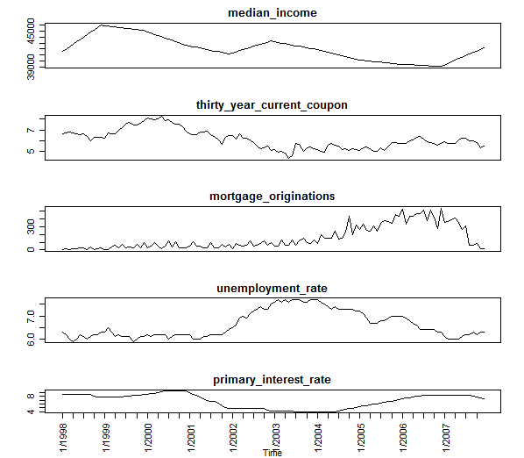

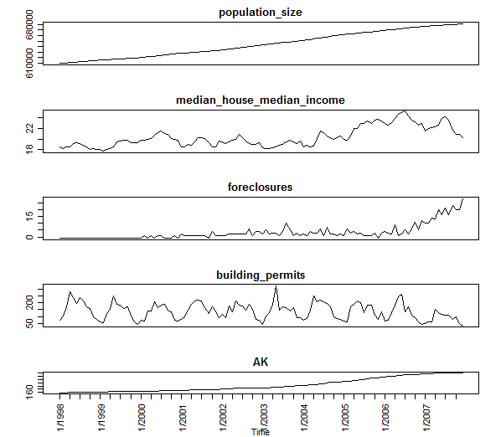

Time Series Plots of Monthly Linearly Interpolated Data Simple Returns

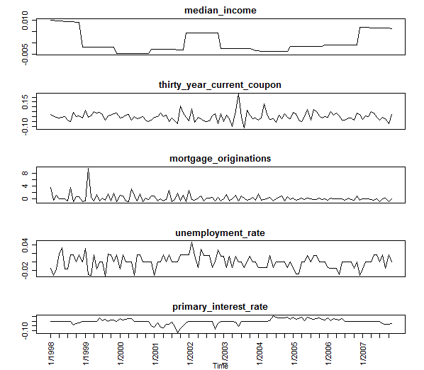

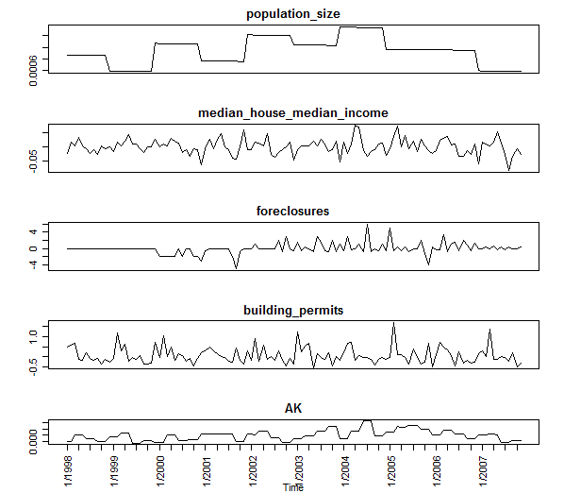

ACF/CCF of Monthly Linearly Interpolated Data

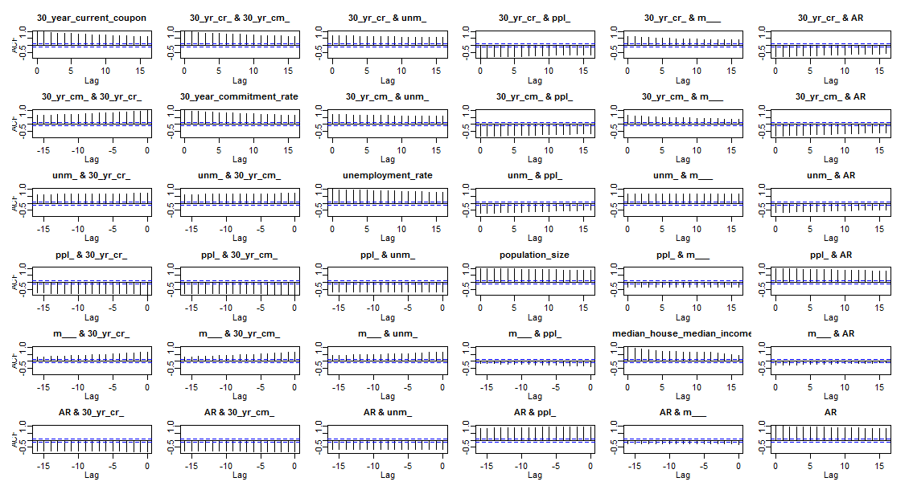

ACF/CCF of Monthly Linearly Interpolated Data-Simple Returns

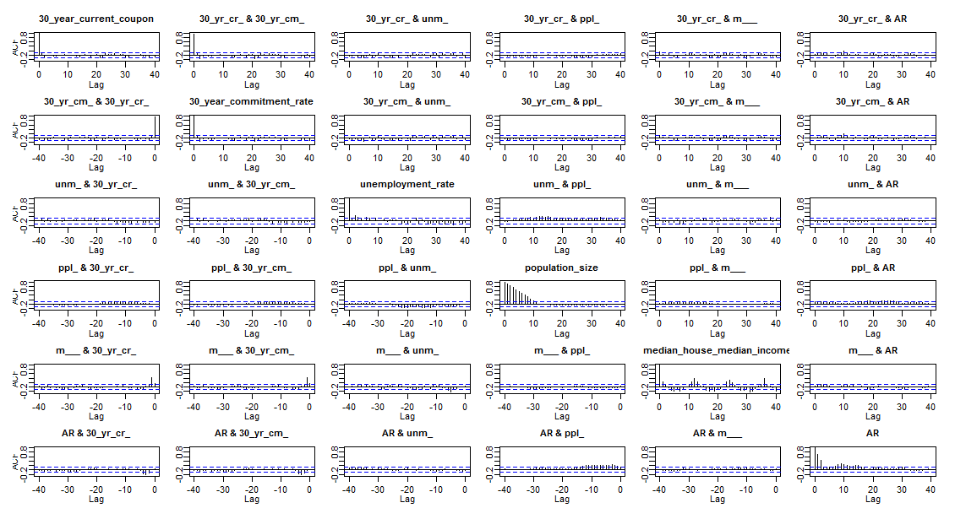

Scatterplot of Monthly Linearly Interpolated Data

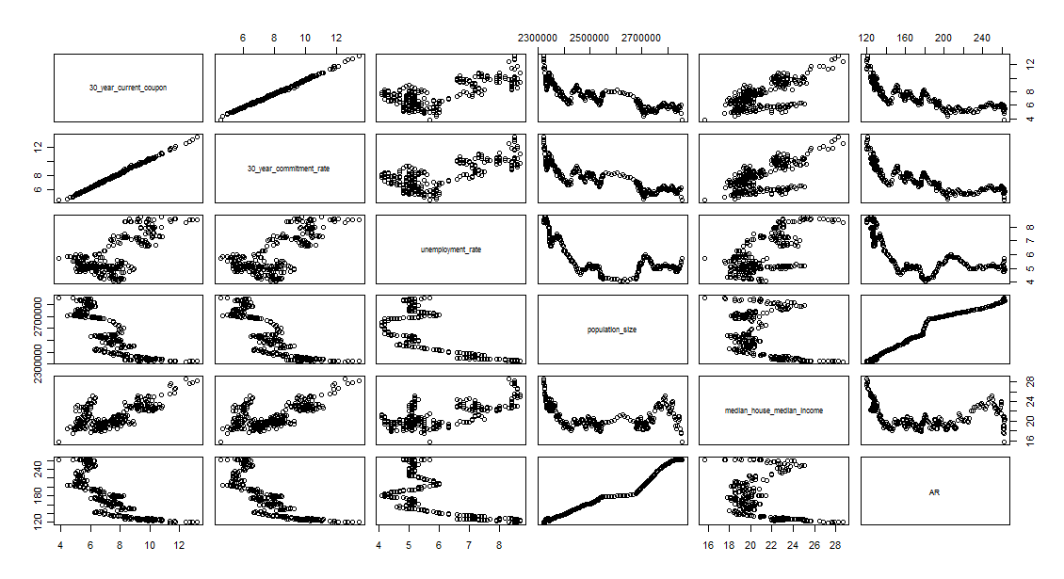

Scatterplot of Monthly Linearly Interpolated Data-Simple Returns

